Instructions On How To Save Youtube Videos To You Digital Sandbox Account
Go to youtube.com and find a video you want to use. It will have a “Share” button below it. Click on the “share” button and copy the url in the box
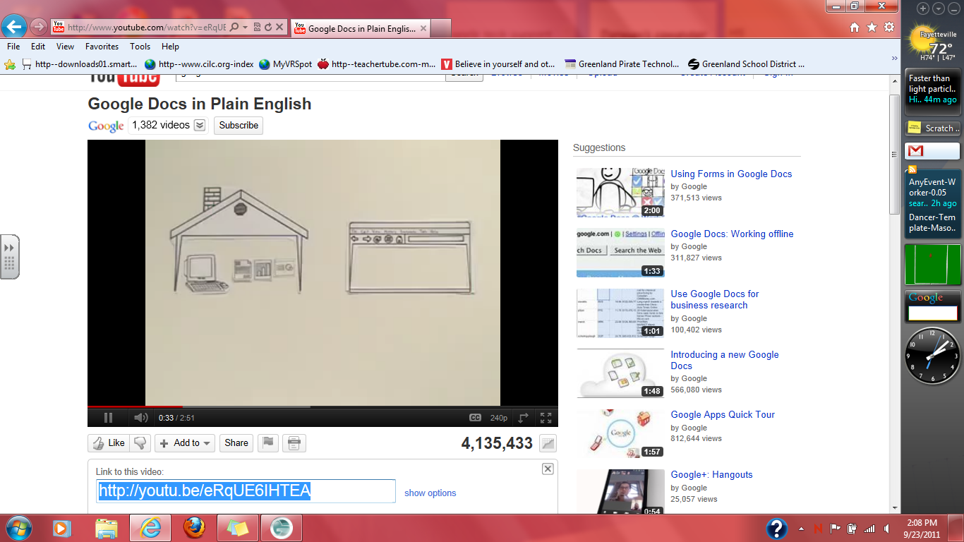

Open up digital sandbox to your account. Your Username is “Your First name. Last name with no spaces” Your password is : password. Your password can be change after you login the first time. Click on “upload Video” and on the right side of the screen you will click on “upload video from link”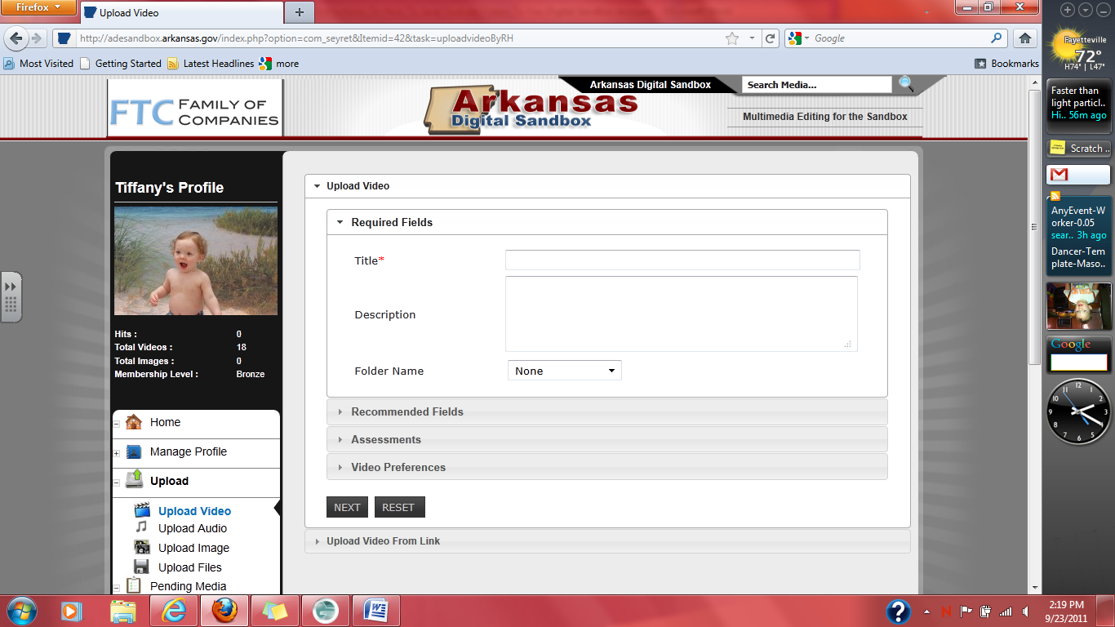

Then paste the youtube url into the box provided and click apply and fill in blanks concerning your video and save
